**Department of Mechanical Engineering**

**GED 1201 Engineering Mechanics (Tutorials)**

**Part B and C type of problems**

1. Determine the centroid for the sections shown in figure 1 and 2. Assume all dimensions in meter.

2. Determine the centroid for the section shown in figure 3.

3. Determine product moment of inertia about the centroidal axis for the section shown in figure 4.

(Solution: Product moment of inertia is given or determined by the equation, (IXY = A1X1Y1 + A2X2Y2 +…….+ AnXnYn)

4. Derive the centroid for the rectangle, and right angle triangle.

(Solution: You need to derive the X and Y formula for the above shapes, refer to text books for the derivative part it’s like basic mathematical derivative).

**Part A type of questions**

1. What is the need to determine centroid?

2. Differentiate between centroid and centre of gravity.

3. State the objective in representing moment of inertia.

4. Define parallel axis theorem.

5. State perpendicular axis theorem.

6. Write the centroid along X and Y axis for a rectangle.

7. Write the centroid along X and Y axis for a quarter-circle.

8. Give the relation for product moment of inertia.

9. What is the relation between inertia and bending stress?

10. Write the moment of inertia equation about XX and YY axis.

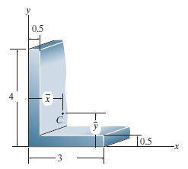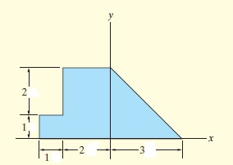

**Figure 1 Figure 2**

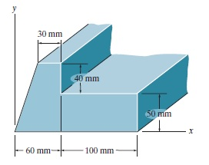

**Figure 3**

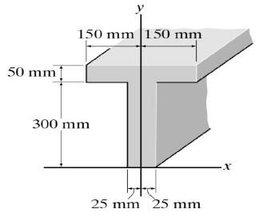

**Figure 4**